REVIEW: WRITE THE TITLE IN ENGLISH THAT REFLECTS THE RESEARCH WORK AND FINDINGS (MAXIMUM 15 WORDS, CENTER, BOLD, 14pt)

REVIEW: WRITE THE ENGLISH TITLE THAT TRANSLATES THE ENGLISH TITLE (MAXIMUM 15 WORDS, CENTER, BOLD, ITALIC, 14pt)

First Author¹, Second Author², Third Author³ (12pt)
Note; put *) after the author's name if they are the corresponding author. If the authors are from the same institution, simply use the same institution symbol (^{1,2,3}...)
¹Faculty, University, Country (11pt)
²Faculty, University, Country (11pt)
³Faculty, University, Country (11pt)
*Email Corresponding : write down the email address and phone number of the corresponding author, who may not be the first author (11 pt)

Submitted :........................ Revised :.......................... Accepted:.....................

ABSTRACT (11pt, space 1)
The abstract does not have to be a word-for-word translation of the Indonesian abstract but should have the same content. The format is the same as the Indonesian abstract, but it should also not exceed 250 words. The purpose and methodology should be written in the past tense, while the results and conclusions should be written in the present tense.

Keywords: please write down 3 to 6 keywords

INTRODUCTION (11pt)
The manuscript is written in Indonesian or English using Times New Roman font, 1 (one) column, 1-spaced, on A4 paper. The author is requested to submit a typed MS-Word file. The number of paragraphs is not limited, but it should cover the background, research objectives, the position of the research in relation to previous research, and the novelty of the research. A little theoretical background directly related to the content of the article may be included. Subheadings (sub-chapters) do not need to be included in the introduction.

RESEARCH METHOD (11pt)
The research method consists of 3 sub-chapters: tools and materials, criteria for article selection, and research procedures. If the data analysis is specific or the analysis method is new, a sub-chapter on Data Analysis can be added. The sub-chapters should be written without numbering or bullet points.

Tools and Materials
Include the tools or databases used to search for articles, such as Google Scholar, ScienceDirect, PubMed, and others. Explain if any specific software or assistance tools were used, such as RevMan® (Review Manager), Mendeley®, and others.

Article Selection Criteria
Explain the inclusion and exclusion criteria for the review study.

Research Procedure
This section describes how the review process was conducted, from article search, selection, data extraction, processing, data analysis to presenting the review results.

RESULTS AND DISCUSSION (11pt)
Results and discussion include three things: (1) a description, (2) interpretation (explanation) of the research results, and (3) a discussion (comparison) of our results with previous research results. If the results and discussion section is very long, sub-sections can be created with Arabic numbering. The description of the results can be in the form of tables and figures with sequential numbers (Tables use Roman numerals, Figures use Arabic numerals) according to their placement in the manuscript, as shown in the example below:

Table I. Formulation of Effervescent Granules of Mangosteen Fruit Peel Dry Extract

Component | Formula ( mg )
 | I | II | III
Mangosteen fruit peel extract (maltodextrin) | 100 | 100 | 100
Effervesent mix
- Citric acid | 375 | 328 | 281
- Tartaric acid | 750 | 656 | 563
- Sodium bicarbonate | 1,275 | 1,116 | 956
PGA Solution 1% | qs | qs | qs
Blackcurrent Dye | 1 | 1 | 1
Aspartame | 15 | 15 | 15
Lactose | 484 | 784 | 1,084
Total | 3000 | 3000 | 3000

Note:
F I :
F II :
F III :

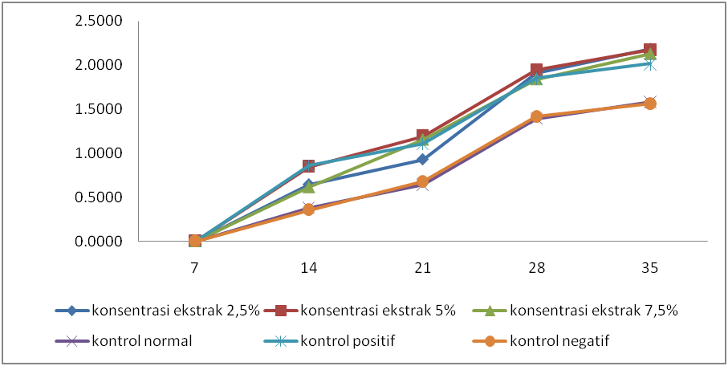

Figure 1. Hair growth rate from day 7 to day 35

CONCLUSION (11pt)
The conclusion is written in one paragraph, without citation.

ACKNOWLEDGEMENTS (11pt)
If necessary, such as to acknowledge funding sources, technicians, and discussion partners, this section can be included.

REFERENCES (11pt)
The reference list prioritizes the last 10 years (minimum of 75% of at least 10 references cited). The reference list is written in alphabetical order chronologically without numbering (Harvard System). The reference list uses the latest references and the Mendeley application for citation and references.

Journal articles, bulletins, and scientific magazines (periodicals).
Example: Coss, P., Ying, L., Calomme,M., J.P. Cimanga, K., Van Poel, B., Pieters,L., Vlietinck., A.J., and Vanden Berghe, D, 1998, Structure-Activity Relationship and Classification of Flavonoids as Inhibitors of Xanthine Oxidase and Superoxide Scavengers, J. Nat. Prod. 61 : 71-76.

For a book of collected articles (review)
Example: Olive, P.J.W. 1983. Annelida-Polychaeta. in K.G. Adiyodi and A.R.Adiyodi., Reproductive Biologi of Invertebrates. John Willey and Sons. Chichester. New York. 357-442.

For a textbook Example: Guenther. 1952. The Essential Oil. Vol 5. Van Nostrand Reinhodl Company. New York. 34-36

For Proceedings Author,
year of proceeding, article title, in Proceedings of... (seminar/conference name), organizer of the seminar (or publisher of the proceedings), city where the seminar was held (or city of the publisher), 34-39.

