WRITE A TITLE IN ENGLISH THAT REFLECTS THE WORK AND RESULTS OF THE RESEARCH (MAXIMUM 15 WORDS, CENTERED, BOLD, 14pt)

First Author¹, Second Author², Third Author³ (12pt)
Note; put *) after the author's name if they are the corresponding author. If the authors are from the same institution, simply use the same institution symbol (^{1,2,3}...)
¹Faculty, University, Country (11pt)
²Faculty, University, Country (11pt)
³Faculty, University, Country (11pt)
*Email Corresponding : write down the email address and phone number of the corresponding author, who may not be the first author (11 pt)

Submitted :........................ Revised :.......................... Accepted:.....................

ABSTRACT (11pt, Space 1)
The abstract does not have to be a word-for-word translation of the abstract, but it should have the same content. The format is the same as the abstract, but it should be no more than 250 words. The objectives and methods are written in past tense, while the results and conclusions are written in present tense.

Keywords: please write down 3 to 6 keywords

INTRODUCTION (11pt)
The manuscript is written in Indonesian or English using Times New Roman font, 1 (one) column, 1-spaced, on A4 paper. The author is requested to submit the typed manuscript in MS-Word format.
The number of paragraphs is not limited, but they should include the background, research objectives, the position of the research in relation to previous research, and the novelty of the research. A little theoretical foundation directly related to the contents of the article may be included. Sub-headings (sub-chapters) do not need to be made in the introduction.

RESEARCH METHODS (11pt)
The research method consists of two sub-chapters, namely the equipment and materials, and the course of the research. If the data analysis is specific, or the analysis method is new, then a sub-chapter on Data Analysis can be added. The sub-chapter is written without numbering or bullet points.

Equipment and Materials
List the large or special equipment used in the research, including the brand, type, and specifications. Common laboratory equipment such as glassware, droppers, scalpels, and the like, need not be mentioned. Specific/special equipment, such as custom-designed or modified standard equipment, should be accompanied by a diagram/photo of the equipment. The degree and specifications of the materials, brand, and supplier for each material must be mentioned. The gender, strain, age, and average weight and SD of the test animals should be reported in this section. If the crude drugs were obtained by self-collection from living plants, as far as possible, the age of the plant/fruit/leaf position, month of collection, and time of collection should be mentioned. If purchased, the source of the purchase should be stated.

Research Procedure
This section contains the specific research procedures used in the study. A simple workflow need not be made into a diagram. Common working procedures need not be explained in detail. Long research steps can be made into sub-chapters of research stages with Arabic numbering.
- Step I research
Explain the research steps briefly but clearly, making it possible for other researchers to replicate the same results.
- Step II research, etc.

Data Analysis
New data analysis methods must be explained in detail along with their formulas (equations). If the manuscript contains more than three equations, the equations must be numbered.

RESULTS AND DISCUSSION (11pt)
Results and discussion contain three things: (1) description and (2) interpretation (explanation) of the research results and (3) discussion (comparison) of our results with previous research results. If the results and discussion subchapter are very long, sub-sub-chapters can be made with Arabic numbering. Result descriptions can be in the form of tables and figures with sequential numbers (Tables using Roman numerals, Figures using Arabic numerals) according to their location in the manuscript, as in the following example:

Table I. Formulation of Mangosteen Peel Dry Extract Effervescent Granules

Component | Formula ( mg )
 | I | II | III
Mangosteen Peel Extract (maltodextrin) | 100 | 100 | 100
Effervescent mix
- Citric Acid | 375 | 328 | 281
- Tartaric Acid | 750 | 656 | 563
- Sodium Bicarbonate | 1,275 | 1,116 | 956
PGA Solution 1% | qs | qs | qs
Blackcurrant Dye | 1 | 1 | 1
Aspartame | 15 | 15 | 15
Lactose | 484 | 784 | 1,084
Total | 3000 | 3000 | 3000

Note:
F I :
F II :
F III :

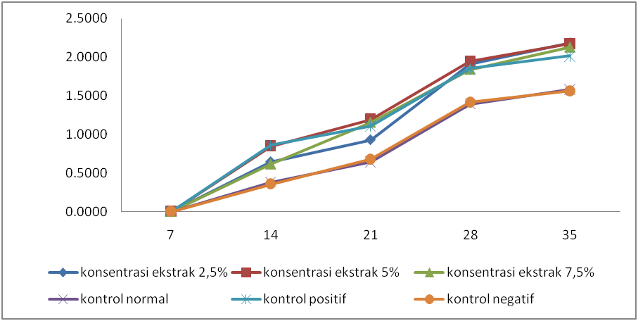

Figure 1. Hair growth rate on day 7 to day 35

CONCLUSION (11pt)
The conclusion is written in one paragraph without citation.

ACKNOWLEDGMENT (11pt)
If deemed necessary, such as for funders, technicians, and discussion partners, it can be written in this section.

REFERENCES (11pt)
The reference list should include sources from the last 10 years, and at least 80% of the minimum of 15 references cited should be journal articles. The reference list should be arranged alphabetically and chronologically without numbering (Harvard System). Use the latest references and Mendeley application for citation and references.

Journal articles, bulletins, and scientific magazines (periodicals):
Example: Coss, P., Ying, L., Calomme,M., J.P. Cimanga, K., Van Poel, B., Pieters,L., Vlietinck., A.J., and Vanden Berghe, D, 1998, Structure-Activity Relationship and Classification of Flavonoids as Inhibitors of Xanthine Oxidase and Superoxide Scavengers, J. Nat. Prod. 61 : 71-76.

For edited book chapters (reviews):
Example: Olive, P.J.W. 1983. Annelida-Polychaeta. in K.G. Adiyodi and A.R.Adiyodi., Reproductive Biology of Invertebrates. John Willey and Sons. Chichester. New York. 357-442.

For textbooks:
Example: Guenther. 1952. The Essential Oil. Vol 5. Van Nostrand Reinhodl Company. New York. 34-36

For conference proceedings:
Author, year of proceedings, article title, in Proceedings of…(name of seminar/conference), seminar organizer (or proceedings publisher), city of seminar (or publisher city), 34-39.

